Module 3
Assignment 1
Cypress Debugging
The following Cypress test fails randomly:
cy.visit("/login")
cy.get("#username").type("admin")
cy.get("#password").type("Cisco123")
cy.get("#login").click()
cy.get("#dashboard").should("be.visible")
Questions:
1. List four possible reasons for the intermittent failure.
2. How would you debug the issue?
3. How would you improve the script to make it more stable?
4. What additional validations would you include?
Answers:
1.Reason 1 : Page loads slowly
Suppose
Browser opens
↓
Login button appears
↓
Backend is still loading
↓
Dashboard takes 5 seconds
But Cypress checks after only 2 seconds.
Result
Dashboard not found
Test fails.
This is called Timing Issue
Reason 2 : Slow Backend API
Imagine
Click Login
↓
Application sends request
POST /login
↓
Server validates
↓
Returns Dashboard
If server is busy,
response comes after
8 seconds
Sometimes
1 second
Hence random failures.
Reason 3 : Element not yet visible
Maybe Dashboard HTML exists
but
display:none
or
Animation still running.
Cypress says Element exists but Not visible
Hence failure.
Reason 4 : Network issues
Suppose internet is slow.
Resources load late.
Images
CSS
JavaScript
API
Everything becomes slower.

Result
Dashboard never loads within timeout.
Other valid reasons include:
- Database delay
- Browser cache
- Session timeout
- Authentication issues
- Wrong test data
- Dynamic element IDs
- Application bug
---------------------------------------------------------------------------------------
- Debugging means
Find the actual reason behind failure.
Method 1 : Cypress Test Runner
Run
npx cypress open
Watch every step.
Observe where it fails.
Method 2 :
Use
cy.pause()
Example:
cy.visit("/login")
cy.pause()
cy.get("#username").type("admin")
Execution pauses.
Inspect page.
Continue manually.
Very useful.
Method 3 :
Use
cy.log()
Example:
cy.log("Entering username")
cy.get("#username").type("admin")
cy.log("Clicking Login")
Output
Entering username
Clicking Login
Helps identify which step failed.
Method 4
Browser Developer Tools
Press
F12
Check
Network tab
Console tab
Errors
Failed API
HTTP 500
JavaScript errors
Method 5 : Screenshot
cy.screenshot()
If failure occurs,
see exactly what page looked like.
Method 6 : Video recording
Cypress records entire execution.
Useful for CI/CD pipelines.
-------------------------------------------------------------------------------------
- Improvement 1 : Wait for API
Instead of checking immediately
cy.intercept("POST","/login").as("loginRequest")
cy.get("#login").click()
cy.wait("@loginRequest")
Now Cypress waits until login completes.
Improvement 2 : Increase timeout
cy.get("#dashboard", {
timeout:10000
}).should("be.visible")
Waits
10 seconds
instead of default.
Improvement 3 : Verify URL
cy.url().should("include","dashboard")
Confirms navigation happened.
Improvement 4 : Use stable locators
Instead of
#login
prefer
data-cy="login"
Then
cy.get("[data-cy=login]")
Because CSS IDs/classes may change during development.
Improvement 5 : Avoid unnecessary waits
Never do
cy.wait(5000)
Instead wait for
API
Element
URL
State
---------------------------------------------------------------------------------------
- i) Role-Based Validation
Purpose: Verify the logged-in user is redirected based on the correct role (e.g., Admin).
cy.get("#userRole")
.should("be.visible")
.and("contain", "Admin")
Or, if the application displays a role-specific menu:
cy.get("#adminMenu").should("be.visible")
ii) URL Validation
Purpose: Verify the application redirects to the correct page after login.
cy.url().should("include", "/dashboard")
iii) Login API Response Validation
Purpose: Verify the backend successfully authenticates the user.
cy.intercept("POST", "/login").as("loginRequest")
cy.get("#login").click()
cy.wait("@loginRequest")
.its("response.statusCode")
.should("eq", 200)
iv) User Information / Welcome Message Validation
Purpose: Verify the correct user has logged in.
cy.contains("Welcome Admin").should("be.visible")
Or
cy.get("#usernameDisplay")
.should("contain", "admin")
v) Logout Validation
Purpose: Verify the Logout button is available and works correctly.
cy.get("#logout").click()
cy.url().should("include", "/login")
cy.get("#login").should("be.visible")

Assignment 2
testbed.yaml
testbed:
name: Cisco_Testbed

devices:
Router1:
os: ios
type: router
connections:
cli:
protocol: ssh
ip: 192.168.1.101
Switch1:
os: iosxe
type: switch
connections:
cli:
protocol: ssh
ip: 192.168.1.102
Switch2:
os: nxos
type: switch
connections:
cli:
protocol: ssh
ip: 192.168.1.103

device_info.py
import csv

devices = [
{
"name": "Router1",
"platform": "IOS",
"version": "Cisco IOS 15.8",
"inventory": "Cisco ISR4321"
},
{
"name": "Switch1",
"platform": "IOS-XE",
"version": "Cisco IOS-XE 17.3",
"inventory": "Catalyst 9300"
},
{
"name": "Switch2",
"platform": "NX-OS",
"version": "NX-OS 10.2",
"inventory": "Nexus 9000"
}
]
try:
with open("report.csv", "w", newline="") as file:
writer = csv.writer(file)
writer.writerow([
"Device",
"Platform",
"Show Version",
"Show Inventory",
"Status"
])
for device in devices:
print(f"\nConnecting to {device['name']}...")
print("Executing: show version")
print("Executing: show inventory")
writer.writerow([
device["name"],
device["platform"],
device["version"],
device["inventory"],
"Success"
])
print("\nCSV Report Generated Successfully!")
except Exception as e:
print("Error:", e)

O/P
Connecting to Router1...

Executing: show version

Executing: show inventory

Connecting to Switch1...

Executing: show version

Executing: show inventory

Connecting to Switch2...

Executing: show version

Executing: show inventory

CSV Report Generated Successfully!
report.csv
Device,Platform,Show Version,Show Inventory,Status
Router1,IOS,Cisco IOS 15.8,Cisco ISR4321,Success
Switch1,IOS-XE,Cisco IOS-XE 17.3,Catalyst 9300,Success
Switch2,NX-OS,NX-OS 10.2,Nexus 9000,Success

Assignment 3
Test Scenario
- Launch the OrangeHRM application.
- Log in with valid credentials.
- Navigate to the PIM module.
- Click Add Employee.
- Enter employee details.
- Save the employee information.
- Validate that the Personal Details page is displayed.
loginPage.js
class LoginPage {

visit() {
cy.visit("https://opensource-demo.orangehrmlive.com/web/index.php/auth/login")
}
login(username, password) {
cy.get('input[name="username"]').type(username)
cy.get('input[name="password"]').type(password)
cy.get('button[type="submit"]').click()
}
}
export default LoginPage

dashboardPage.js
class DashboardPage {

openPIM() {
cy.contains("PIM").click()
}
}
export default DashboardPage

employeePage.js
class EmployeePage {

clickAdd() {
cy.contains("Add").click()
}
enterEmployee(firstName, lastName) {
cy.get('input[name="firstName"]').type(firstName)
cy.get('input[name="lastName"]').type(lastName)
}
saveEmployee() {
cy.contains("Save").click()
}
verifyEmployee() {
cy.contains("Personal Details").should("be.visible")
}
}
export default EmployeePage

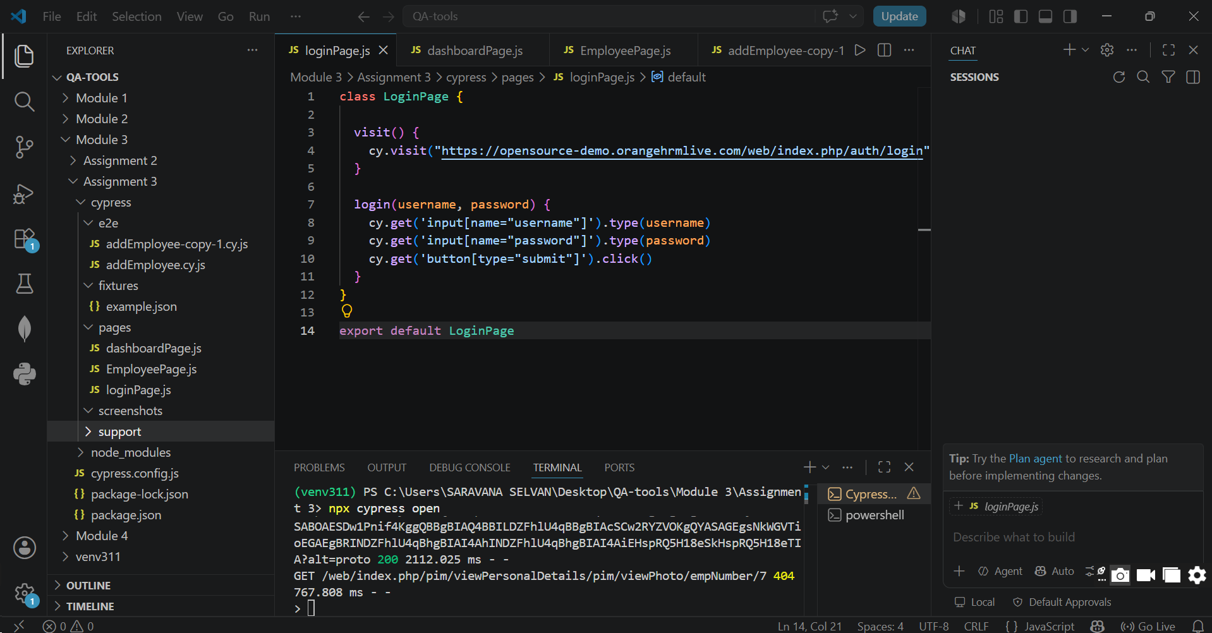
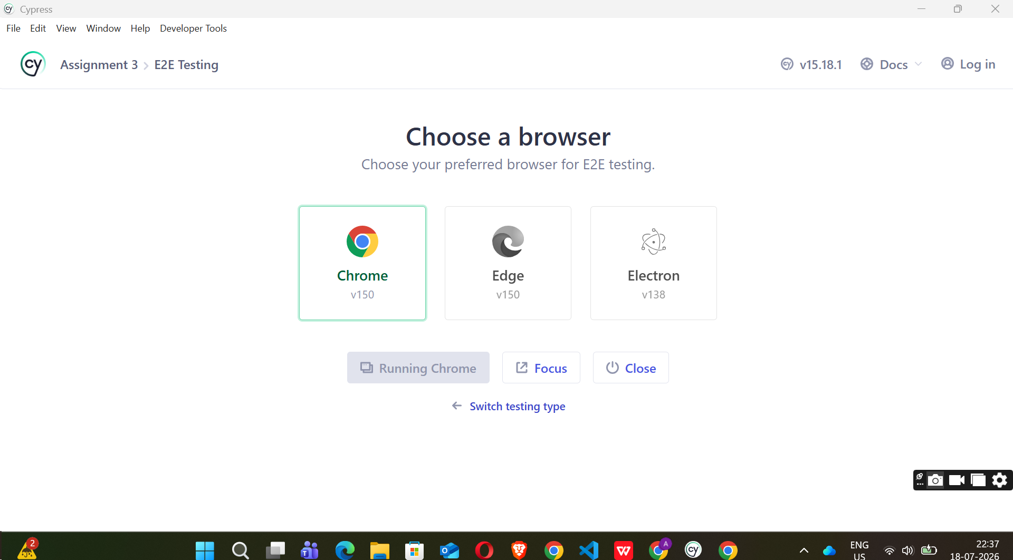
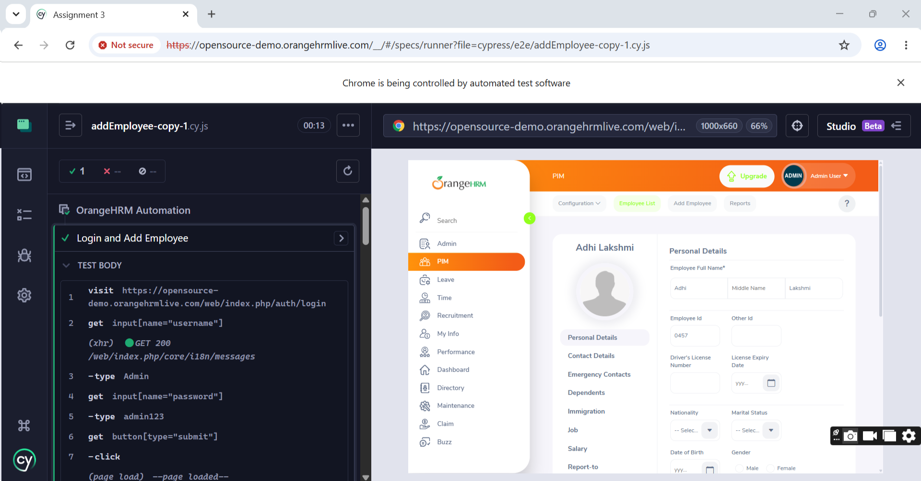
Assignment 4
Step 1 – Verify Device Connection
Command:
adb devices
Purpose:
Checks whether the Android device is connected to the computer.
Sample Output:
List of devices attached

R58N12345AB device
Step 2 – Install Application
Command:
adb install DemoApp.apk
Purpose:
Installs the APK file on the connected Android device.
Sample Output:
Performing Streamed Install
Success

Step 3 – Launch Application
Command:
adb shell monkey -p com.demo.app -c android.intent.category.LAUNCHER 1
Purpose:
Launches the installed application.
Sample Output:
Events injected: 1
The application opens successfully.
Step 4 – Perform Login
Test Data:
Username : testuser
Password : test123
Action:
Enter the username and password in the application login screen and tap the Login button.
Expected Result:
Login Successful
Home Screen Displayed

Step 5 – Capture Screenshot
Command:
adb exec-out screencap -p > screenshot.png
Purpose:
Captures the current screen and saves it as screenshot.png.
Sample Output:
Screenshot saved successfully as screenshot.png
Step 6 – Collect Logcat Logs
Command:
adb logcat > logcat.txt
Press Ctrl + C after a few seconds.
Purpose:
Captures Android system logs and stores them in a text file.
Sample Output:
--------- beginning of main
--------- beginning of system
07-18 10:30:25.123 1542 1542 I ActivityManager: Displayed com.demo.app/.MainActivity

Step 7 – Uninstall Application
Command:
adb uninstall com.demo.app
Purpose:
Removes the installed application from the Android device.
Sample Output:
Success
Summary Table
Step | Command | Expected Output
Verify Device | adb devices | R58N12345AB device
Install App | adb install DemoApp.apk | Success
Launch App | adb shell monkey -p com.demo.app -c android.intent.category.LAUNCHER 1 | Events injected: 1
Login | Manual | Login Successful
Capture Screenshot | adb exec-out screencap -p > screenshot.png | screenshot.png created
Collect Logs | adb logcat > logcat.txt | logcat.txt created
Uninstall App | adb uninstall com.demo.app | Success

Assignment 5
testbed.yaml
testbed:
name: Cisco_Testbed

devices:
Router1:
os: ios
platform: IOS
type: router
connections:
cli:
protocol: ssh
ip: 192.168.1.101
Switch1:
os: iosxe
platform: IOS-XE
type: switch
connections:
cli:
protocol: ssh
ip: 192.168.1.102
Switch2:
os: nxos
platform: NX-OS
type: switch
connections:
cli:
protocol: ssh
ip: 192.168.1.103

Config_backup.py
import os
import csv
from datetime import datetime

# Simulated device details
devices = [
{
"name": "Router1",
"platform": "IOS"
},
{
"name": "Switch1",
"platform": "IOS-XE"
},
{
"name": "Switch2",
"platform": "NX-OS"
}
]
# Create timestamped backup folder
timestamp = datetime.now().strftime("%Y-%m-%d_%H-%M-%S")
backup_folder = os.path.join("backups", timestamp)
os.makedirs(backup_folder, exist_ok=True)
csv_file = "backup_report.csv"
try:
with open(csv_file, "w", newline="") as report:
writer = csv.writer(report)
writer.writerow([
"Device Name",
"Platform",
"Status",
"Backup File Name",
"Backup Date"
])
for device in devices:
print(f"Connecting to {device['name']}...")
# Simulated configuration
configuration = f"""
hostname {device['name']}
interface GigabitEthernet0/0
ip address dhcp
line console 0
login
"""
filename = f"{device['name']}_config.txt"
filepath = os.path.join(
backup_folder,
filename
)
with open(filepath, "w") as backup:
backup.write(configuration)
writer.writerow([
device["name"],
device["platform"],
"Success",
filename,
datetime.now().strftime("%Y-%m-%d %H:%M:%S")
])
print(f"Backup completed for {device['name']}")
print("\nCSV Report Generated Successfully!")
except Exception as e:
print("Error:", e)

backup_report.csv
Device Name,Platform,Status,Backup File Name,Backup Date
Router1,IOS,Success,Router1_config.txt,2026-07-18 22:30:15
Switch1,IOS-XE,Success,Switch1_config.txt,2026-07-18 22:30:15
Switch2,NX-OS,Success,Switch2_config.txt,2026-07-18 22:30:15
Sample O/P
Connecting to Router1...
Backup completed for Router1

Connecting to Switch1...
Backup completed for Switch1

Connecting to Switch2...
Backup completed for Switch2

CSV Report Generated Successfully!

Sample Router1_config.txt
hostname Router1

interface GigabitEthernet0/0
ip address dhcp

line console 0
login

Assignment 6
1. Verify whether the phone is connected
Command:
adb devices
Purpose:
Displays the list of Android devices connected to the computer.
Expected Output:
List of devices attached
R58N12345AB device

2. Identify the device model
Command:
adb shell getprop ro.product.model

Purpose:
Displays the model name of the connected Android device.
Expected Output:
Samsung Galaxy A34
(The output depends on phone model.)
3. Open the Wi-Fi Settings page
Command:
adb shell am start -a android.settings.WIFI_SETTINGS
Purpose:
Launches the Wi-Fi Settings screen on the Android device.
Expected Output:
The Wi-Fi Settings page opens on the device.
4. Enter the Wi-Fi SSID "Cisco_Test"
ADB cannot reliably type into the Wi-Fi dialog because it depends on the device's UI and security restrictions.
A basic automation approach is:
adb shell input text Cisco_Test
Purpose:
Types the text Cisco_Test into the currently focused text field.
Expected Output:
The SSID field displays:
Cisco_Test
5. Why must USB Debugging be enabled?
USB Debugging allows the computer to communicate with the Android device using ADB (Android Debug Bridge). It enables developers and testers to execute commands, install applications, capture logs, take screenshots, and automate device operations. Without USB Debugging, ADB commands cannot control or communicate with the device.
Summary Table
Command | Purpose | Expected Output
adb devices | Verify connected devices | Device listed with status device
adb shell getprop ro.product.model | Get device model | Model name displayed
adb shell am start -a android.settings.WIFI_SETTINGS | Open Wi-Fi Settings | Wi-Fi settings screen opens
adb shell input text Cisco_Test | Enter Wi-Fi SSID | SSID field contains "Cisco_Test"

Assignment 7
1. Why is one device shown as "unauthorized"?
The device is shown as unauthorized because the user has not approved the computer's RSA fingerprint for USB debugging. Android requires permission before allowing ADB access.
2. How would you resolve this issue?
Steps to resolve:
Disconnect and reconnect the USB cable.
Ensure USB Debugging is enabled.
Unlock the phone screen.
Accept the "Allow USB debugging?" prompt.
If needed, run:
adb kill-server
adb start-server
adb devices
Reconnect the device if the prompt does not appear.
3. Can automation continue on the unauthorized device? Justify your answer.
No.
Automation cannot continue because ADB commands require an authorized connection. Until the user grants USB debugging permission, the computer cannot install apps, execute commands, capture screenshots, or perform automated testing.
Assignment 8
1. Is the issue likely in the UI or the backend?
The issue is most likely in the backend.
Reason:
The UI successfully performs all user interactions. The login request reaches the server, but the server responds with HTTP 500 Internal Server Error, indicating a server-side failure.
2. Which Cypress feature would help confirm your conclusion?
Use cy.intercept().
Example:
cy.intercept('POST', '**/login').as('loginRequest');
cy.get('button[type="submit"]').click();
cy.wait('@loginRequest');
This captures the network request and response, allowing verification of the HTTP status code.
3. What evidence would you collect before reporting the issue?
Before reporting the issue, collect the following evidence:
- Screenshot of the failed login page.
- Cypress test execution log.
- Network request and response details captured using cy.intercept().
- HTTP status code (500).
- Browser Developer Tools Network tab screenshot.
- Timestamp of the failure.
- Test environment details (browser, application URL, test data used).

